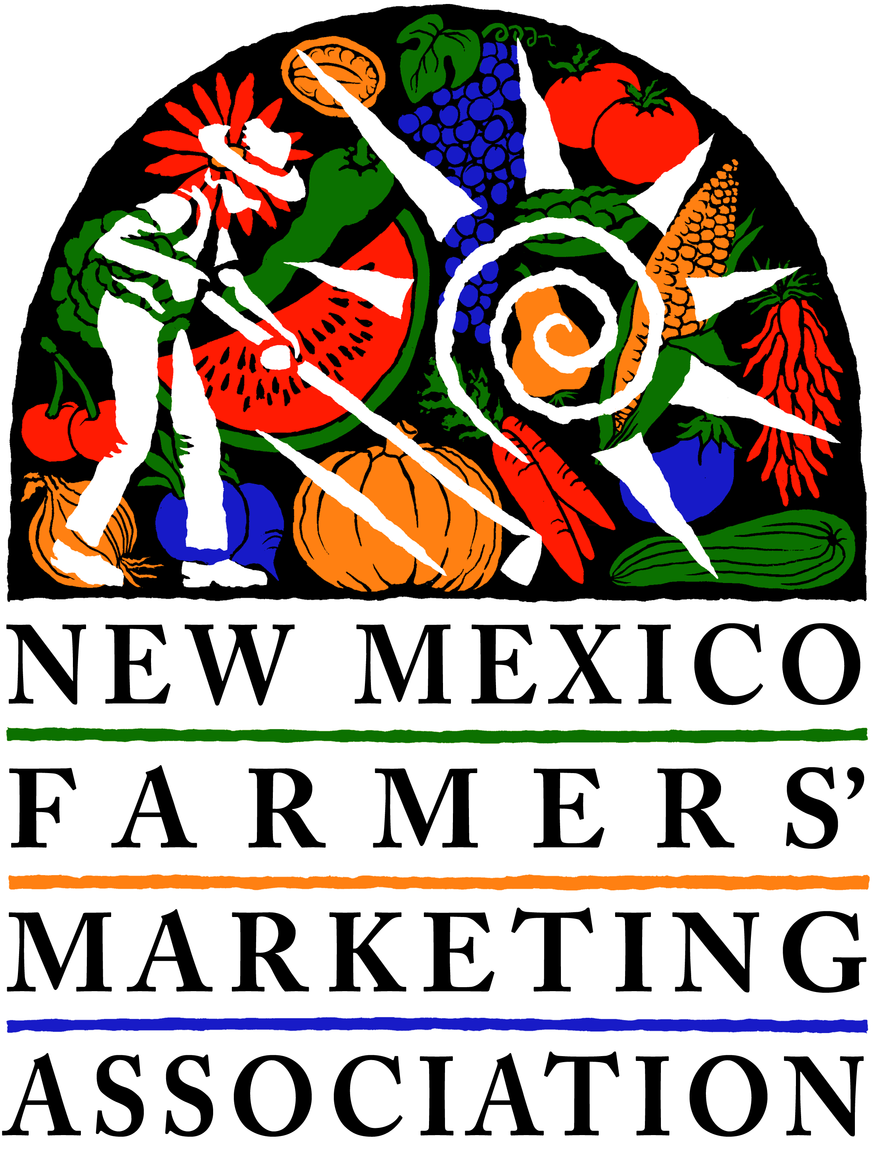

GRANT APPLICATION
Local Innovation Farmer Enterprise (LIFE)
DEADLINE: MARCH 15, 2020

PLEASE READ THE LIFE GRANT BROCHURE FOR FURTHER INFORMATION ABOUT THIS GRANT. Use as much space as needed within text boxes. Email or snail mail to the address on Page 2. We will reply via email to let you know we received your application. If you don’t hear back, please call us. Please note: If you received a LIFE grant in 2019, it is unlikely you will receive another in 2020. If you submitted a proposal last year and did not receive a grant, and would like to re-submit the same proposal, call for feedback if you like.

1. Name
2. Phone number
3. Email address
4. Your farm name
5. Farm location (town, city, or county)
6. How many acres do you typically farm for vegetable/fruit production?

7. What are your three principal crops? And approximate volume of each?

Crops | Estimated Pounds Per Year
#1
#2
#3

6. What type of project do you have in mind? (Please check)

________ Wholesale crop project
________Regenerative agriculture project (If yes, please address specific topics in Question 9A)

7. Project Name _____________________________________________________________________________

8. What amount of grant money are you requesting? $__________________________________
Maximum grant amount is $3,000, but smaller amounts are fine. Don’t forget, this is a cost-share project, so you will need to “match” the requested amount either with in-kind or actual spending on your end.

9. Project Description. We understand that one growing season will not be enough to measure certain results from certain projects. However, please describe what you will be able to learn within one growing season.

A. Goal(s): What do you hope to accomplish? If you are considering a regenerative project, discuss how you plan to address any or all of the 5 Key Principles of Soil Health (soil armor, minimizing soil disturbance, plant diversity, continual live plant/root, livestock integration). More information on this can be found at https://www.nrcs.usda.gov/wps/portal/nrcs/main/nd/soils/health/
or many other sites about healthy soil.

B. Timing: Why are you tackling this problem or challenge now? (ie., opportunities in the marketplace, timing for your operation, etc.)

C. Deliverables/Outcomes: 1. What measureable results do you anticipate? 2. How will you measure them? For example, you might expect to increase your carrot production from 500 pounds to 2,000 pounds, to be measured by output and sales. Or, you might plan to improve your soil and build a bioreactor, and will test your soil before and after.

1.
2.
etc.

D. Work Plan: What activities will you be undertaking, when, and who will be responsible for the activity? Be as specific as possible. For WHEN, you can estimate month. For WHO, if you will be using a consultant or contractor but don’t know who it will be, just put “Contractor, “ “Consultant” “Hired Labor” etc. Please add lines as needed.

Activity | When | Who
1.
2.
3.
4.
5.
6.
7.
8.
9.
10.

E. Sharing: Does the project involve any sharing of resources? If so, please describe.
For example, if you intend to purchase or rent equipment, do you plan to share it with other farmers? If you are creating labels or packaging, will that be shared with any other farmers?

10. Please use the Budget Template provided to show how the grant will be used, and what your sources of “match” are. Be as specific as possible for all costs. Use hourly rates, mileage, and specific cost estimates. Use the Budget Template EXAMPLE for guidance.

11. How do you hope to incorporate results of this project into your future farming business?

GRANT DEADLINE: March 15, 2020
QUESTIONS? E-mail or call:
Ashley Taylor, ashley@farmersmarketsnm.org, 505-983-4010, x1
OR Sarah Grant, sarahg@farmersmarketsnm.org, 505-983-4010 x2

NMFMA • 1219 Luisa, Unit 1 • Santa Fe, NM 87505

